Ledgerly – How to Use
Never be surprised by a bill again – a private tracker for subscriptions, bills, free trials and renewals.

What it does
- Dashboard with your true monthly and yearly cost, money left after bills, what is due in 7 or 30 days, and a 12-month projection.
- Calendar of every payment, trial end and renewal.
- Free-trial warnings before you are charged.
- Renewals for 19 document types (passport, driving licence, MOT, car tax, TV licence and more) with links to GOV.UK.
- Insights that find savings: duplicate services, price rises, unused subscriptions, cheaper annual plans.
- Cancellation links for 86 built-in UK services.
- Export to calendar (.ics), CSV or a full backup. Dark mode, 17 currencies (GBP default).
- Private: no account, no bank login, no server – data stays in your browser.

How to open it on Windows

Option 1 – just open it
Double-click index.html in the ledgerly folder. Everything works in Chrome or Edge.

Option 2 – installable offline app (recommended)
1. Double-click start.bat.
2. Your browser opens http://localhost:8080 (next free port if busy).
3. Keep the black window open while you use it.
4. In Chrome or Edge click the install icon in the address bar to get Ledgerly as a desktop app.
Important: the browser keeps data separately for index.html and for localhost:8080. Pick one and stick with it, or move data with Settings → Export backup / Import backup.

Logins
None. Ledgerly has no accounts at all.

Step by step

First start
1. On the welcome screen tap the services you already pay for (from 86 UK services with typical prices), or explore with sample data first.
2. Check and edit the prices to match your own plans.
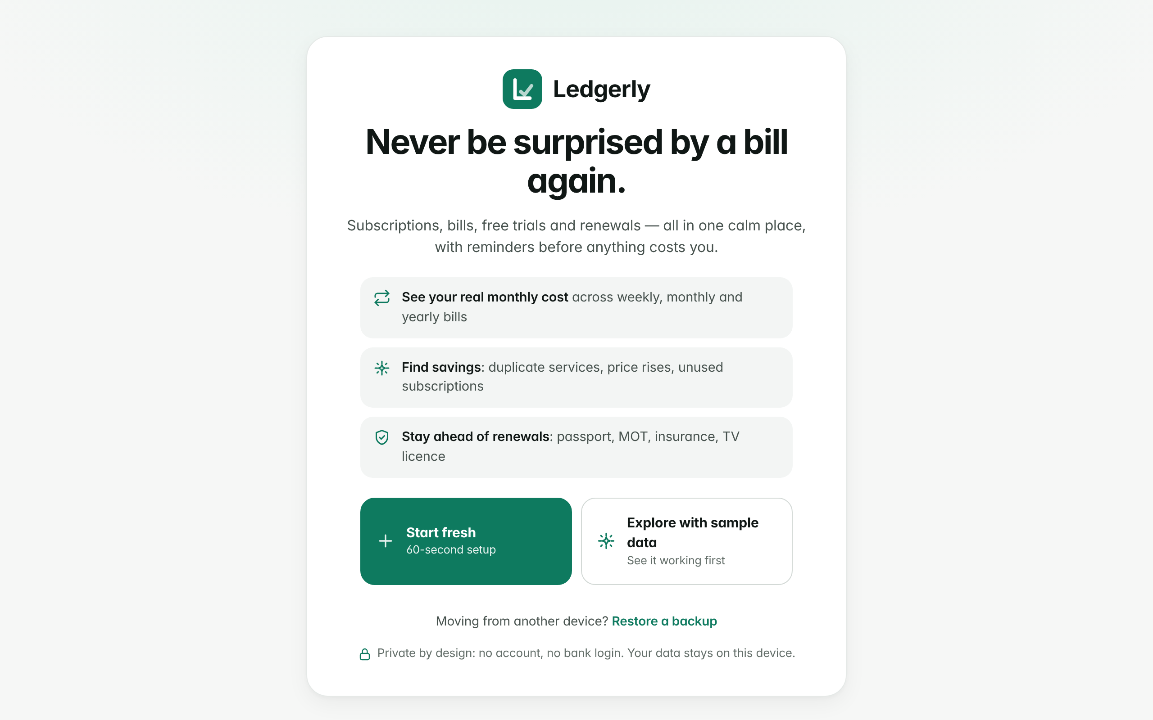
Welcome / onboarding

Add a subscription or bill
1. Click the add button.
2. Pick a service from the library or type your own.
3. Enter the price, how often it is charged and the next date. For a free trial, enter the trial end and a "cancel by" date.
4. Save. It now appears on the dashboard and calendar.
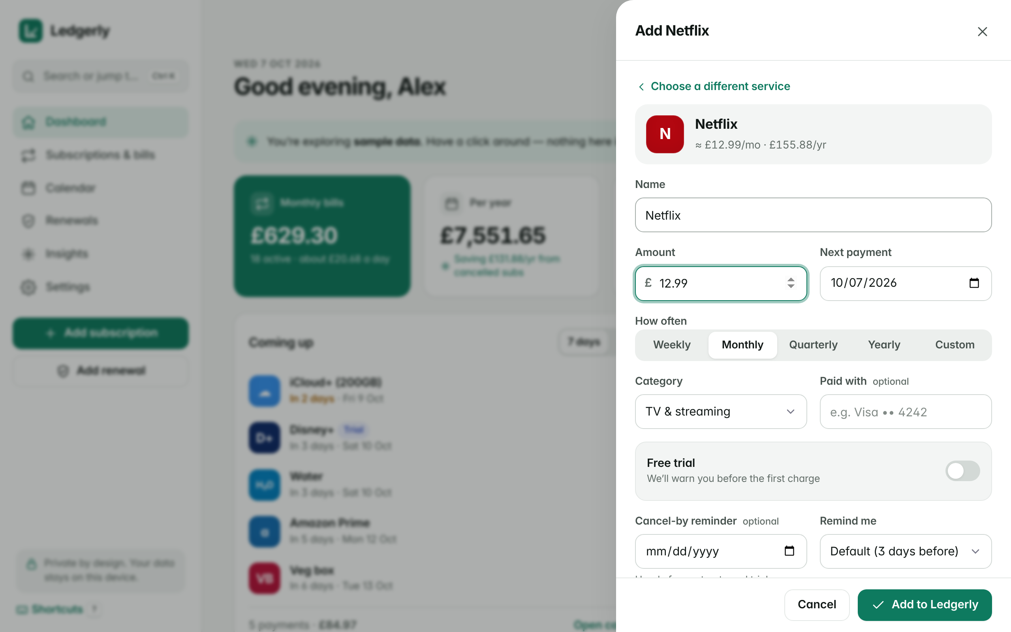
Adding a subscription

Find savings
1. Open Insights.
2. Read each tip – click "Why am I seeing this?" for the reason.
3. Use the cancellation link if you want to cancel a service.
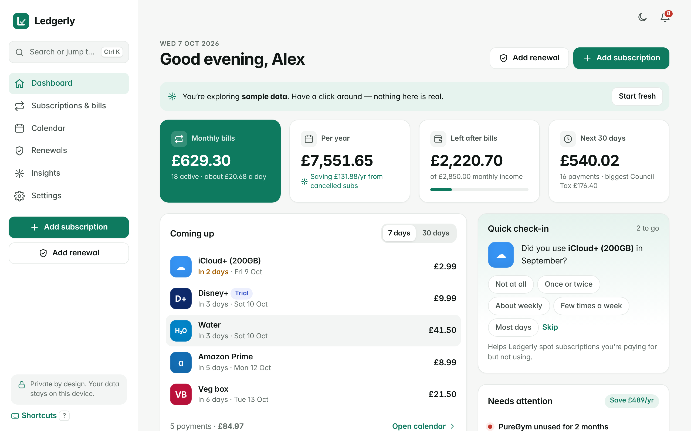
The dashboard

Handy extras
- Press Ctrl + K to jump anywhere or add from the library.
- Press ? for keyboard shortcuts.
- Export to your calendar (.ics) so reminders fire even when Ledgerly is closed.

Your data, backup and reset
Data is saved in your browser's local storage on this computer. Use Settings → Export backup regularly. Settings also lets you export CSV for Excel, import a backup, or delete everything in one click. Clearing your browser data also erases Ledgerly.

Troubleshooting
Problem | What to do
My data is missing | You may have opened the other version (index.html vs localhost:8080). Open the one you used before, or import a backup.
start.bat opened index.html instead | Node.js was not found. Install Node.js 24 from nodejs.org, or just keep using index.html.
Port 8080 is busy | Close the other program; the app also tries the next free port – read the black window.
No install icon in the browser | Install needs start.bat (localhost), not index.html. Use Chrome or Edge.

Honest limitations
- No bank connection – you add what you pay for.
- Browser notifications only fire while Ledgerly is open; use the .ics calendar export for reminders.
- Changing currency changes the symbol only, not the amounts.
- Library prices are typical UK prices – check them.
- One browser on one device; no cloud sync (by design).

